
Man’s best friend needs care too,
so do what I do and come rescue.
Join us in giving these rescues
your love,
care,
& needed friendship.
Volunteer today!

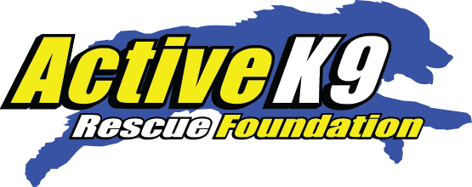
Visit: www.Activek9utah.org.
www.Activek9utah.com or call: 435-901-4349

