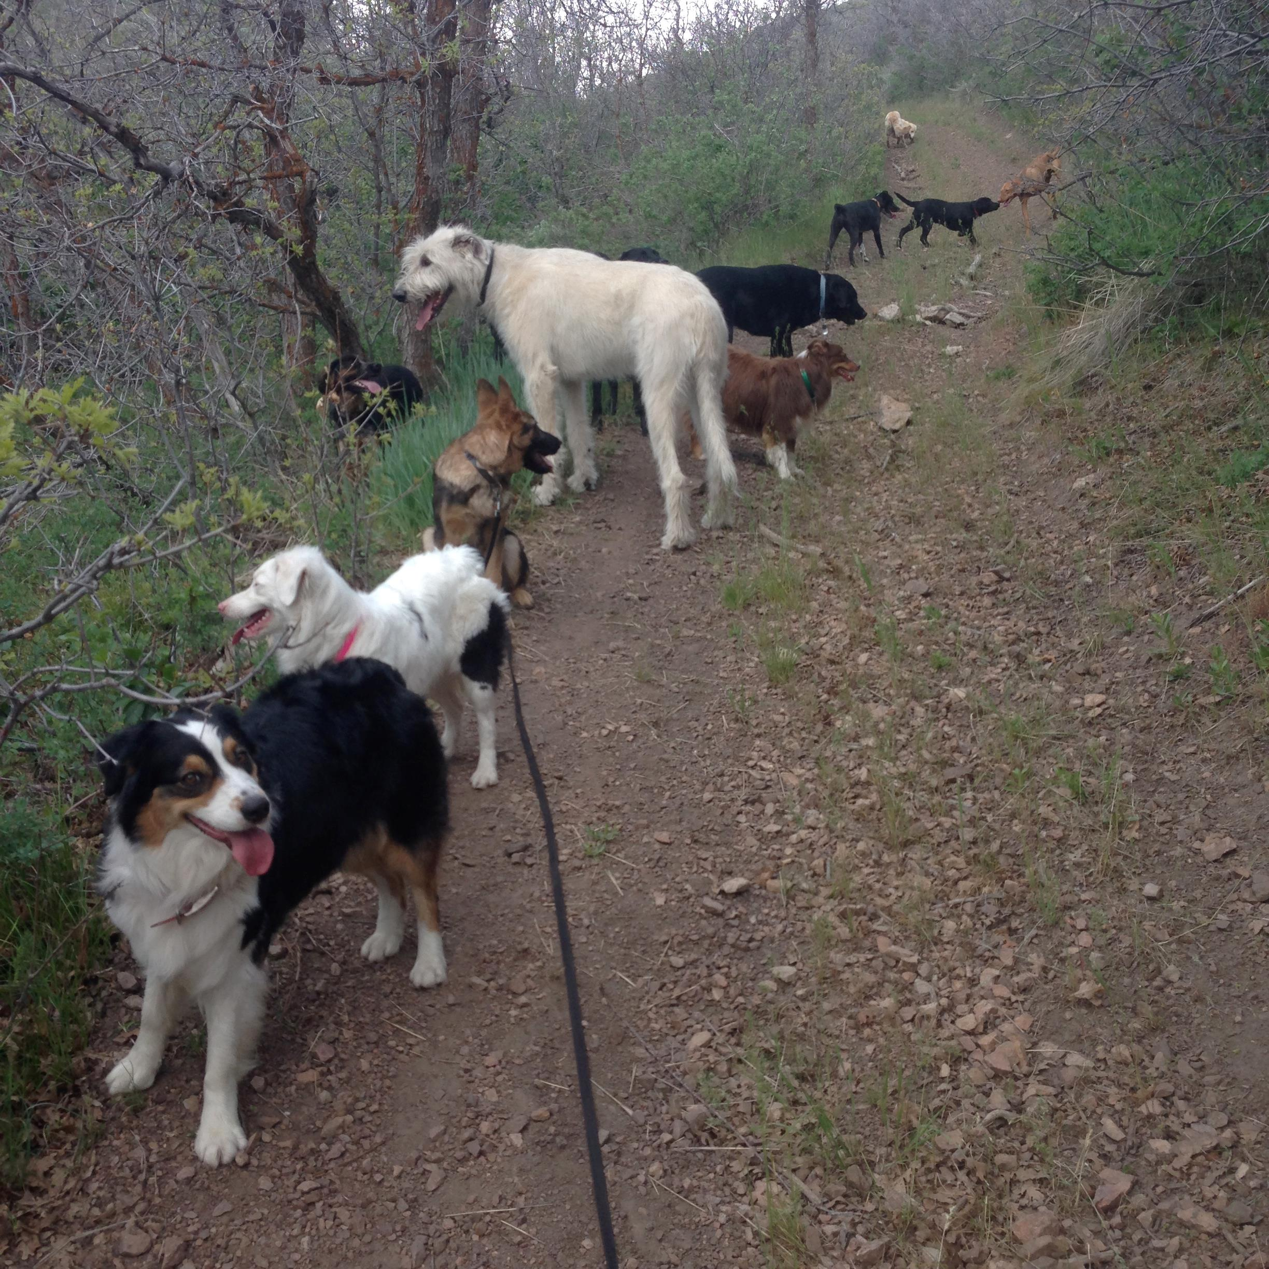
Extend your family.
Become a part of theirs.

Spend some time training
a companion who will always
be overjoyed to see you.
Come in, volunteer, and change their world
for the better!

Visit: www.Activek9utah.org
www.Activek9utah.com
Or call: 435-901-4349 to see what you can do.
6450 Highland Dr. Park City, UT 84098

