To the CEO,

In regards to the recent approval of the natural gas wells near Vernal, Utah, my team and I have prepared a report for you to peruse to approve the direction of construction of the pipeline leading to the refinery. We will outline several options as a comparison and conclude with what we believe to be the most cost effective approach to the construction of the pipeline.

- We will begin with the option to first run the line West, then South and finally to the East, while still on BLM ground. As can be seen in Figure A-1 below.

- Running West, South, then East to the refinery:
- Cost of materials, labor and fees = $250,000 per mile
- Miles(x) = 7 miles West + 18 miles South + 35 miles East = 60 miles
Cost [C(x)] = $250,000x $→$ $250,000*(60) = $15,000,000

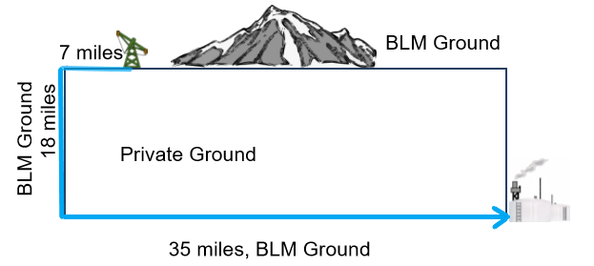
Figure A-1

- The next scenario would be running the pipeline through the mountain to the East, causing a delay of 3 months to the project and incurring a mass of additional charges. This option allows us to run strictly though BLM ground as well. As can be seen in Figure A-2 below.

- East through the mountain, then South to the refinery:
- Cost of materials, labor and fees = $250,000 per mile
- Drilling through the mountain = additional $3,200,000 total
- Environmental impact study = additional $400,000
- Delay 3 months = additional $120,000 per month
- Miles (x) = 28 miles East + 18 miles South = 46 miles
C(x) = $250,000x + $3,960,000 $→$ $250,000*(46) + $3,960,000 = $15,460,000

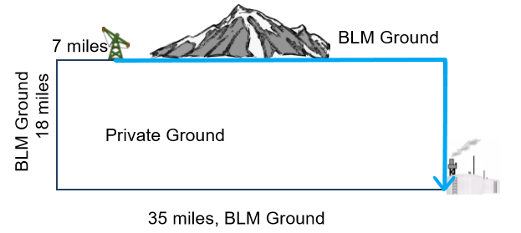
Figure A-2

- We have also considered running the pipeline strictly through private ground as shown, at the shortest distance. As can be seen in Figure B-1 below.

- Shortest distance through private ground:
- Cost of materials, labor and fees = $250,000 per mile
- Right-of-way fees = $75,000 per mile
Here, we calculate the diagonal distance between the well and the refinery by use of the Pythagorean Theorem. With use of the 18 miles heading South and the remaining 28 miles heading East, we are able to calculate the approximate value of miles.
- Miles(x) = $\sqrt{{18}^{2}+{28}^{2}}$ = 2$\sqrt{277}$ $≈$ 33.2866 miles
C(x) = $325,000x $→$ $325,000*(2$\sqrt{277}$) = $10,818,156.04

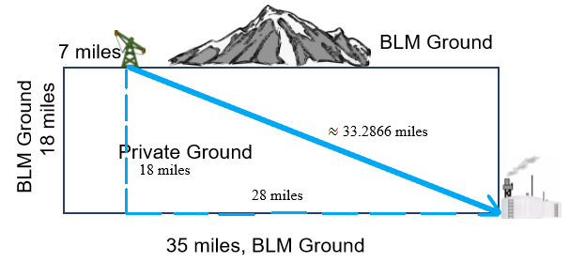Figure B-1

B) Our fourth comparison is a situation in which we run the pipeline directly South through the private ground, then East on BLM ground.

- Straight South across the private ground, then straight East to the refinery:
- Cost of materials, labor and fees = $250,000 per mile
- Right-of-way fees = $75,000 additional per mile
- Miles(x, y) = 18 miles South(y) and 28 miles East(x)
C(x) = $325,000y + $250,000x $→$ $325,000*(18) + $250,000*(28) = $12,850,000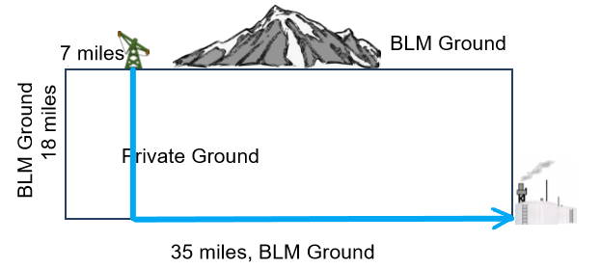Figure B-2

Cost effective solution:

The most cost effective solution is based off of the ideas we had with the fourth and third examples shown previously with the pipeline running through private ground and then through BLM territory. The exception with this route being running the pipeline at a specific angle and distance through the private ground, and then through the BLM ground to optimize costs.
- Cost of materials, labor and fees: $250,000 per mile
- Right-of-way fees = $75,000 additional per mile
- Miles(x, y) = (y) miles South East and (x) miles East
Similar to the previous calculation: C(x) = $325,000y + $250,000(28-x)
In order to calculate the values for the distance heading South East (y) and the distance heading East (28-x), we proceeded as follows:
From the figure, you can see that to find y, we must us the Pythagorean Theorem giving us:
y = $\sqrt{{18}^{2}+x^{2}}$
We can substitute this into the original cost equation to give us:
C(x) = $325,000*($\sqrt{{18}^{2}+x^{2}}$) + $250,000(28-x)
This allows us to have only one variable in our equation, therefore making it simpler. From there what we want to do is take the derivative of the cost function in order to find the point at which the cost is minimal; this is represented in the following calculations as well as the graph below.
C’(x) (derivative) = 325,000*(1/2)*$({\sqrt{{18}^{2}+x^{2}}}^{-1})$*(2x) - 250,000*(-x) $→$
C’(x) = $\frac{325,000x}{\sqrt{324+x^{2}}}$ – 250,000 = 0 $→$ $\frac{325,000x}{\sqrt{324+x^{2}}}$ = 250,000 $→$
325,000x = 250,000*($\sqrt{324+x^{2}}$) $→$
${\left(325,000x\right)}^{2}$ = ${\left(250,000*\left(\sqrt{324+x^{2}}\right)\right)}^{2}$ $→$
${325,000}^{2}x^{2}$ = ${250,000}^{2}*324+{250,000}^{2}x^{2}$ $→$
$x^{2}= \frac{{250,000}^{2}*324}{{325,000}^{2}-{250,000}^{2}}$ $→$
$x≈ \sqrt{469.565217391}$ $→$
$$x≈21.6694535554$$
If we plug in a value smaller than this value into the initial derivative function, it will come up as negative, meaning that the amount of money spent at a distance less than that determined would be decreasing as it approached the optimal distance and inversely for any number above the determined x-value.
Remember that the value x is representative of miles East from the point directly South from the well, on BLM ground to the point where y intercepts the BLM ground. Thus, we can find the value y by substituting the x-value into the Pythagorean Theorem formula previously used as a substitute for y.
y = $\sqrt{324+{21.6694535554}^{2}}$ $→$ $y ≈28.1702896221$
Having determined our x- and y-values, we can now input both into the original cost function.
C(x) = $325,000*($28.1702896221)+$$250,000*($28 - 21.6694535554)$
C(x) = $10,737,989.74
In addition, the law of sines can determine the angle at which we must run the pipeline as follows:
$$\frac{28.1702896221}{Sin(90°)}= \frac{21.6694535554}{Sin(α)}$$
$$Sin\left(α\right)= \frac{21.6694535554}{28.1702896221}$$
$$α≈50.28°$$

$$Sin(β)=\frac{18}{28.1702896221}$$
$$β≈30.72°$$
A visual representation of the previous statements is seen below in Figure C.
Conclusion:
The most effective way to run the pipeline is through the private ground at the calculated angle, to approximately 6.33 miles from the refinery, on BLM ground. This minor difference could save hundreds of thousands of dollars at the very least.
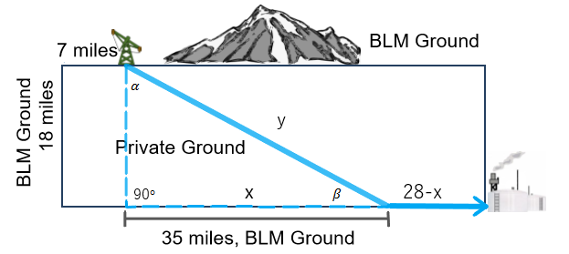
Figure C

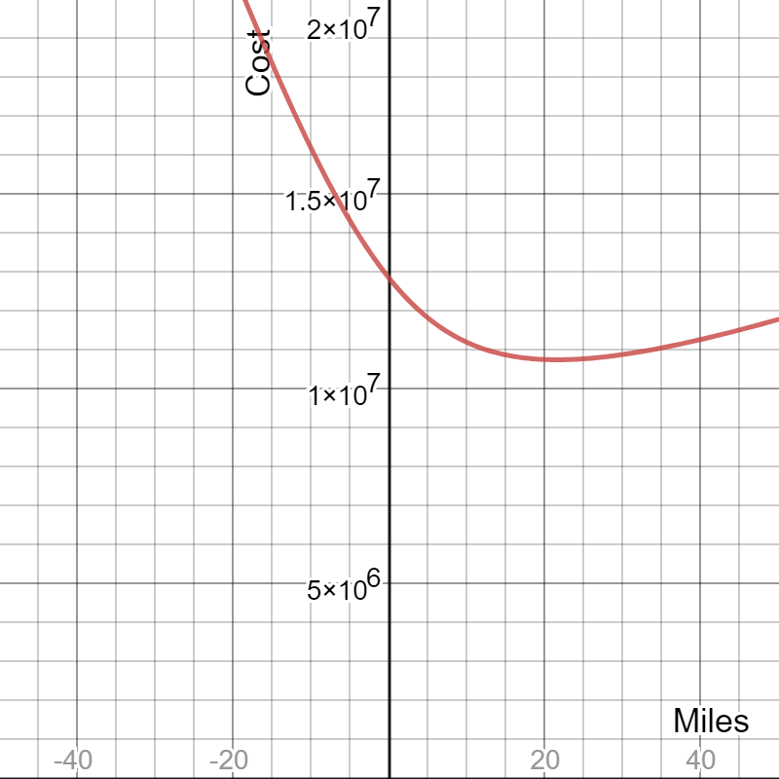
Graph of Cost Function

Reflection
Taking this Calculus course has taught me a lot about derivatives, which seem to be useful in many different fields, including business and engineering, for which I am most interested in. For example, taking derivatives is a key component in doing the math needed to do a cost analysis of product sold by a company in order to maximize revenue. If I were to acquire my MBA in addition to my engineering degree, this would be very beneficial in order to help my company obtain great success. Though it can be impractical in everyday situations, it has its uses such as one of the examples we did in class in which we determined the shortest route to take in regards to time to arrive at a location across a river and down a road. That situation was very similar to this project, which was also a very good example in which understanding calculus is pertinent in obtaining cost/time effective values and has an obvious, realistic use.

